**Bosch Season 7: Release Date | Cast | Plot | Trailer**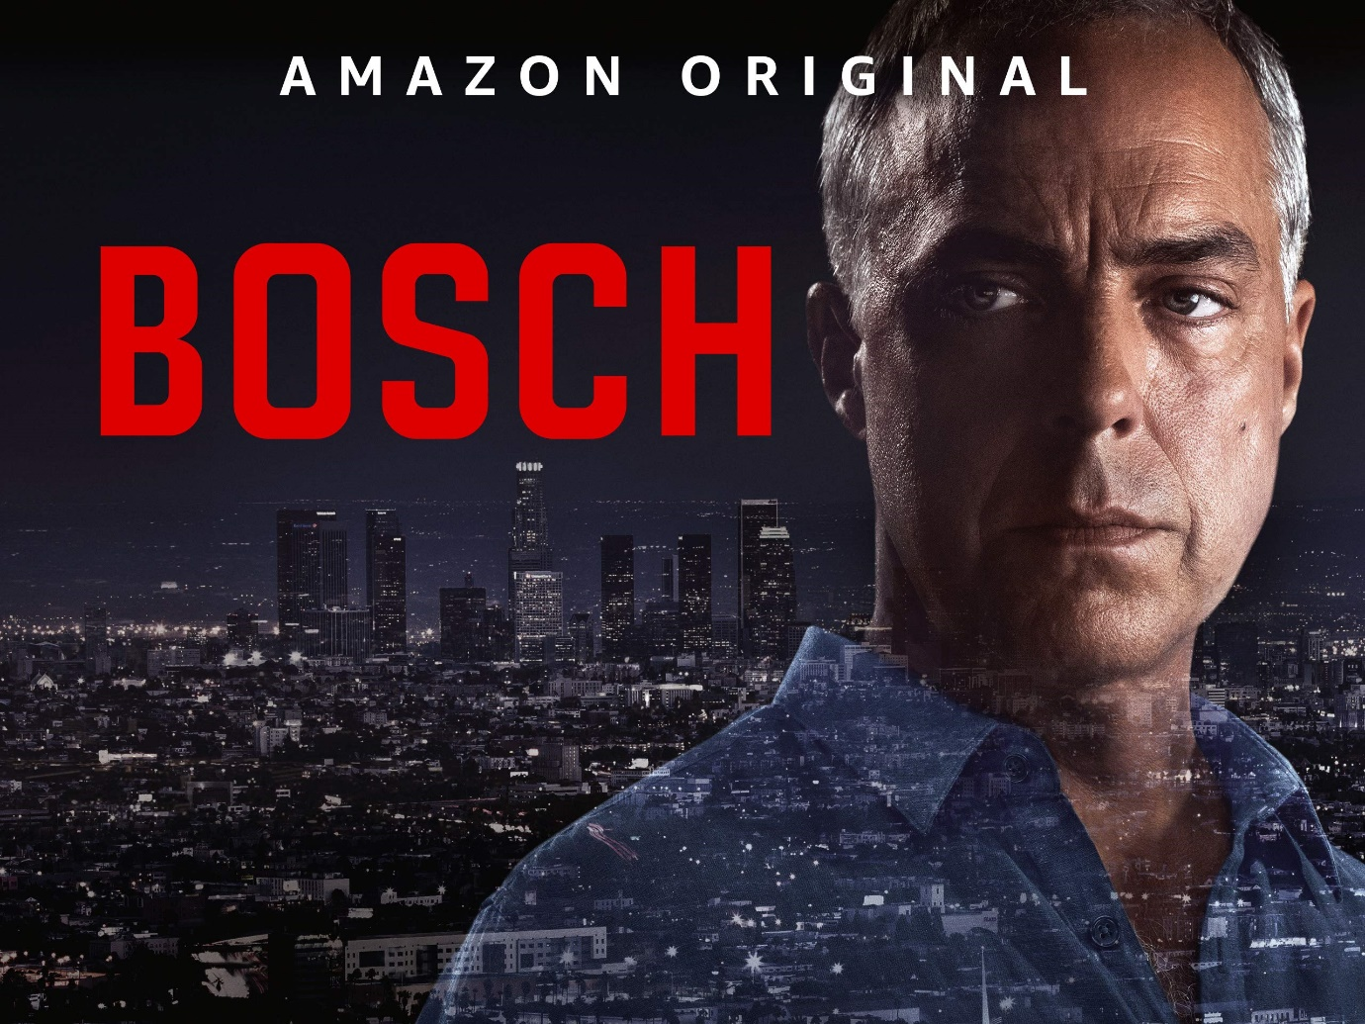

***Bosch***, an American web television series of detective fiction drama genre produced by Amazon Studios and Fabrik entertainment. It was created by Michael Connelly and developed by Eric Overmyer for ***Amazon***.

**Bosch Season 7: Release Date**

The initial production of Bosch was announced by Amazon Studios announced on October 31, 2013. Season 1 streamed on ***Amazon*** from February 6, 2014, to February 13, 2015. Bosch was renewed for Season 2 on March 18, 2015. Season 2 was released on March 11, 2016. Bosch was renewed for Season 3 on April 1, 2016. Season 2 was released on April 21, 2017. Bosch was renewed for Season 4 on October 16, 2016. Season 4 was released on April 13, 2018. Bosch was renewed for Season 5 on February 13, 2018. Season 5 was released on April 19, 2019. Bosch was renewed for Season 6 on November 14, 2018. Season 6 was released on April 16, 2020. ***Bosch*** was renewed for ***Season 7*** on February 13, 2020. As we can see from the pattern that each season is released in April, one year after the announcement of the renewal of the series for that season. So, it's likely that ***Season 7*** will release by mid-April of this year.

**Bosch Season 7: Expected Cast**

Even though there's no official announcement on the characters and actors who're likely to appear in ***season 7*** but it's anticipated that actors and characters from the previous seasons will appear though there may be few more additions it's highly unexpected because ***Season 7*** is going to be the last Season of Bosch which will wrap up all the characters of the show. So, let's catch up on a few characters and actors who're likely to appear in ***season 7*** who appeared in the previous seasons: 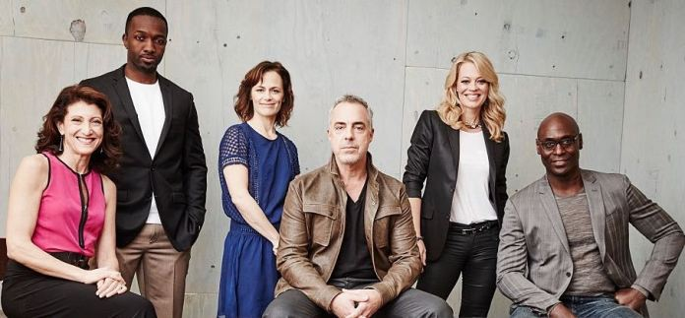

***Titus Welliver*** being Los Angeles Police Department Detective III Hieronymus "Harry" Bosch. He's a former Army Special Forces operative and an expert of the First Gulf War and Afghanistan who used to work in the Hollywood homicide division.

Jamie Hector being Detective II Jerry Edgar. He's Bosch's partner.

Amy Aquino being Lieutenant II Grace Billets. He's Bosch's friend.

Lance Reddick being Chief of Police Irvin Irving

**Bosch Season 7: Expected Plot**

***Bosch Season*** 1 was grounded on novels written by Michael Connelly. The show revolves around Harry Bosch and his LAPD team as they try to grab different suspects. The sixth season of the series was grounded on Connelly's novels The Overlook and Dark Sacred Night. ***Season 7*** is going to be based on the story written by Connelly and the original showrunner Eric Overmyer. It'll be based on the novels The Concrete Blonde and The Burning Room and it's going to show Bosch and Jerry Edgar (Jamie Hector) running behind two different murder investigations trying to solve them. It's likely to focus on white-collar crime and corruption while trying to wrap up all the characters in the **final season** of the show.

**Bosch Season 7: Trailer**

***Bosch Season 7 trailer*** has not been released yet and it's likely to be released in 1 or two months before the ***release*** of ***season 7***. Until you can enjoy the ***trailer*** of ***Bosch Season*** 6😊

https://www.youtube.com/watch?v=bTGPN0Ugt8A